<https://www.udemy.com/course/the-complete-web-development-bootcamp/learn/lecture/12371320#questions/21920126>

**75 Intro to Javascript** – the language that powers the web

Mosaic became Netscape , Netscape lost out to internet explorer Netscape became Mozilla

Back then the code did not run in the browser so web sites were boring.

Javascript was created to run in browser so that sites could do cool stuff without needing to send to server.

You can get an ad free version of websites with JS turned off but stuff will also not work.

Ecma International standardized and continues to standardize it.

Life and times of Internet Explorer

<https://cloud.netlifyusercontent.com/assets/344dbf88-fdf9-42bb-adb4-46f01eedd629/dad7b1cb-2490-48a1-9959-3040a7e0cf27/ie6-comic-strip.jpg>

Interpreters vs compilers video

<https://www.youtube.com/watch?v=_C5AHaS1mOA>

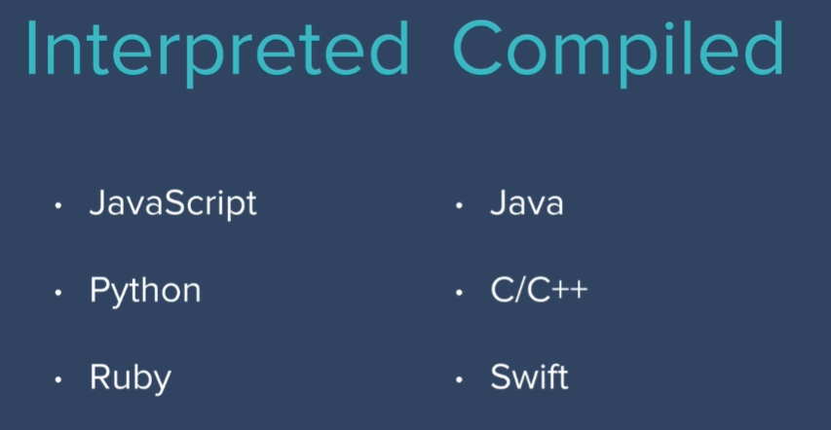

76- Javascript Alerts and adding Behavior to websites

Principles of writing consistent, idiomatic javascript

<https://github.com/rwaldron/idiomatic.js>

Can write little snip it editor to write little bits of code

Shift + Enter can write multiple lines before executing

To create a file to write to in the dev tools , go to Sources then click the double left arrows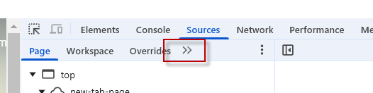

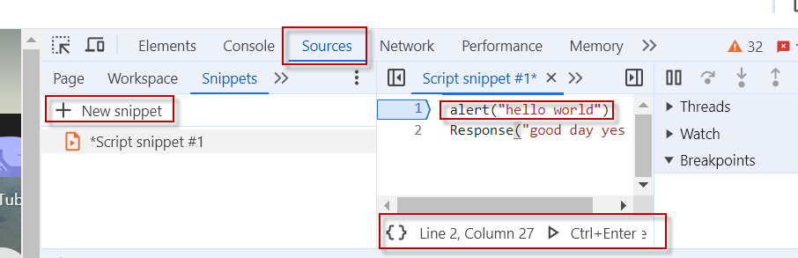

Then run



MDM web docs – good resource

77- Data Types – how do you want javascript to handle what you are inputing

78 Javascript Variables

79 Javascript Variables Exercise Start

Coding Exercise 1

Prompt in index.js -

Variable syntax , setting something to a value

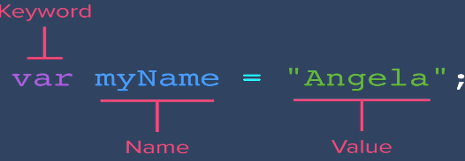

Its like the computer is putting into box

Like switch the buckets around

81 Naming and naming conventions in JS

Camel case is nice

*Note 82-93 I did before but should repeat*

83 – String Concatenation – combine strings with “ “ + “ “ +

84 – slicing and extracting parts of a string – count from 0 as the start position

slice(x,y) x is start positon, y is end position

Slice slices off number of characters in a string from start to end position that is passed in.

A shortcut to know how many characters you're actually slicing is to simply take the upperbound and minus the lower bound.

85 toUppercase() toLowercase()

86 Challenge Change string casing – solution

87 Basic Arithmetic and Modulo operator in JS % useful to find odd / even numbers

If remainer is not 0 its an odd number

88 Increment and decrement

**Post increment** – The post-increment operator (x++) increases the value of x by 1, but it returns the original value of x before the increment. x++ , x— use this in a for loop

let x = 3;

let y = x++;

console.log(y);//will be 3

**Pre increment** - Use the pre-increment operator (++x), which increments x before assigning its value to y.

++x

let x = 4;

let y = ++x;

console.log(y); // y will be 5

**89 create and call function** – function is a block of instructions executed

function getMild(){} -- creates

function() --calls

90 Functions Challenge –

93 Parameters and arguments

Live in weeks coding exercise

95 functions with returns – moduli get remainder

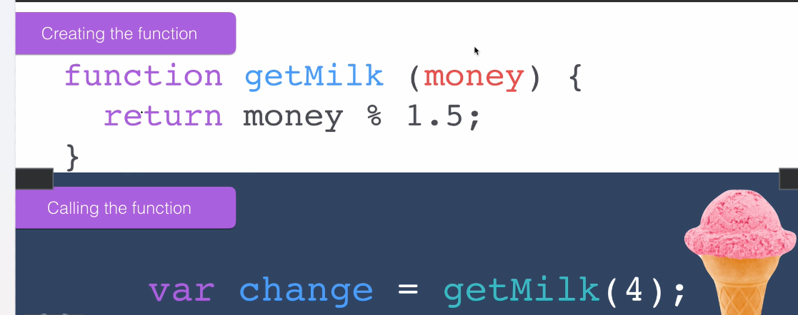

Calling the function and assigning the return or output to a variable

96 create a BMI calculator – restart at this challenge

restart here

<https://www.udemy.com/course/the-complete-web-development-bootcamp/learn/lecture/12373874#overview>